ANGEL ISLAND HIKE
“Mt Livermore via Northridge & Sunset Trails”
Distance: 5.0 miles
Elevation Gain: 744 ft
The loop trail you will be taking is a combination of the Northridge and Sunset trails, with a short out-and-back spur to the summit.
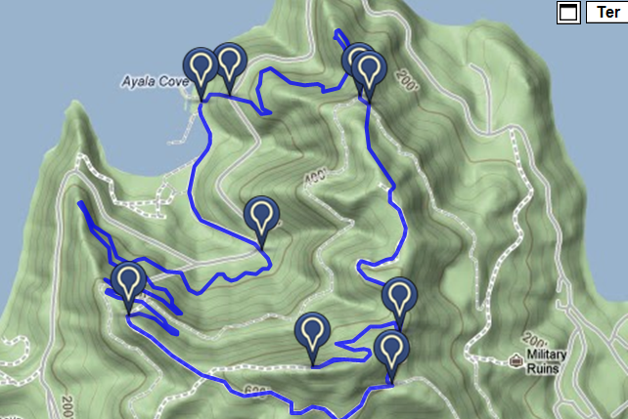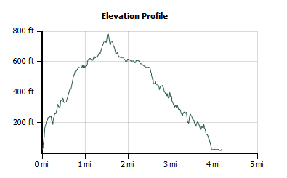
Begin from the ferry landing on Northridge Trail, which sets off to the left (north) of the restrooms. As it leaves the shoreline area, this footpath climbs some long steep stairs past a few picnic tables, then reaches a cluster of eucalyptus and paved Perimeter Road at 0.1 mile.
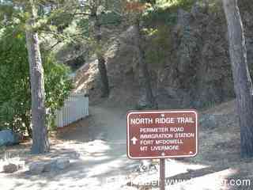

Continue on the far side of the pavement on Northridge Trail. The narrow path winds uphill through shaded woods. When Northridge Trail emerges from the woods on the northernmost flank of the island, enjoy views north across Raccoon Strait to the Tiburon peninsula.
At 0.9 mile, turn left onto a fire road for a few feet, then veer right, continuing on Northridge Trail. After one last foray through chaparral, the path, still ascending easily, takes a long tour through quiet woods of coast live oak. Northridge Trail levels out as it reaches a grassy plateau. There are good views, west to Mount Tamalpais, and uphill to Mount Livermore's summit.
Under a few pines at 1.8 miles, Northridge Trail ends at a T junction. Turn right, following the sign to Mount Livermore. At an easy-going rate, the trail climbs past coast live oak into grassland. After two bends in the trail, the path makes a final push to the summit, climbing through grassy slopes.
At 2.1 miles you'll reach the top of Mount Livermore, where views are simply incredible, and even in summer's haze include the Golden Gate Bridge stretching from San Francisco's Presidio to Marin's rolling Headlands, Alcatraz Island, Mount Tamalpais, the downtown San Francisco skyline, Mount Diablo, Treasure Island, and the Bay Bridge. The picnic table and benches at the summit can be quite windy, but there are a few other sites, off the slopes of the peak, that are more sheltered. It can be tough to leave this idyllic setting, but remember that ferry schedule.
Descend back to the previous junction, then continue, to the right, on Sunset Trail.
Dropping down onto the island's south slope, there are unobstructed views downhill to Point Blunt, an active Coast Guard station. Sunset Trail crosses an old, closed road, and begins to angle across a hillside heading west. Sunset Trail descends a ridge, offering splendid views of Sausalito, Belvedere Island, the Marin Headlands, and Mount Tam, then veers right into coast live oaks woods. At one last little sunny viewpoint a bench invites a lingering break, and the trail then begins a campaign of switchbacks. Some shortcuts are worn into the hillside here, but please stay on the trail, which is well graded.
At 3.5 miles veer right on a fire road for a few feet, and then turn left back onto Sunset Trail. Switchbacks continue, mostly through California bay and coast live oak woods. Just past a water tank and cluster of picnic tables, the trail bends left, runs along the road, and then ends at 4.6 miles. Cross the road near a paved route descending to group picnic areas, then veer right, following the sign to the dock area.
This wide trail starts out paved but soon shifts to dirt. The trail turns sharply left, then ends at the side of the visitor center, where a grassy picnic area fronts the shoreline at Ayala Cove. Turn right and walk on a paved road the remaining distance back to the ferry landing.
FERRY SCHEDULE
Ferry departs Angel Island hourly between 10:20 and 5:20 PM

