Angel Island Trip

A Place Where History Comes Alive

Saturday,

October 11th



#### 

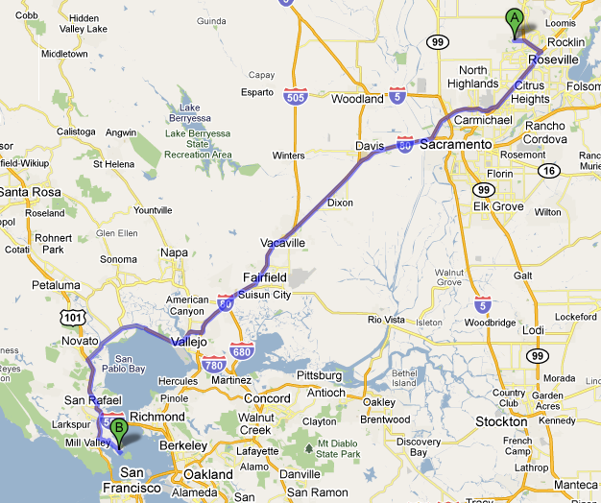

We hope you’re getting excited about a great day on Angel Island. Getting there safely and on time is the first order of business.

We will be meeting at the Safeway parking lot at the corner of Blue Oaks and Woodcreek Oaks Blvd at 7:45 AM on Saturday, October 11th, and leaving promptly at 8:00 AM. Drive time is approximately 2hrs 15 min.

We will be catching the 11:00 AM Ferry. It’s very important that everyone be there on time, so that you don’t miss the boat, literally!

If your family prefers to meet us in Tiburon, please let Steve Brewer, the event coordinator know. Steve can be reached at 916.768.6777 (mobile)

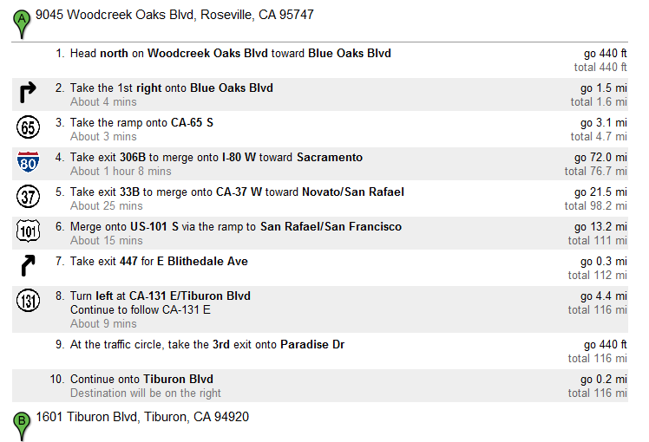

Car Pooling

We encourage you to consider carpooling due to the length of the drive.

A roster will be sent out listing those families that are participating and the number of family members attending

This is a great way to save gas, save money, and meet new people.



We recommend parking in the city parking lot behind the Bank of America building at the corner of Beach Blvd and Tiburon Blvd.

The cost of the city parking lot is $5 for the entire day. The lot is a self-pay lot. There is a machine in the lot where you can purchase a parking ticket. Please make sure to put your ticket on your dashboard.

The walk from the parking lot to the ferry terminal on Main St is approximately a ¼ mile. There is closer parking, but it can cost as much as $20.



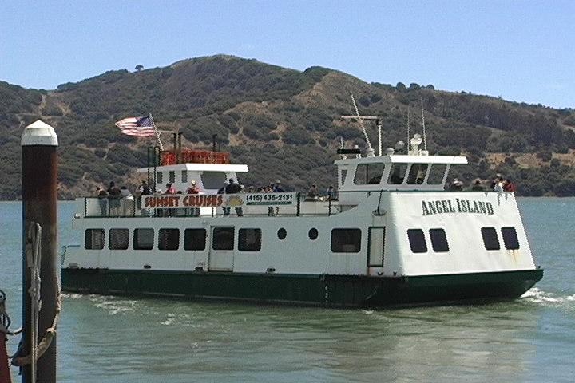

Ferry tickets can be purchased directly at the Ferry Terminal. Ticket prices are as listed below and include entrance fee for Angel Island. The Ferry ride is approximately 20 minutes in duration.  
  
They now accept cash, checks, and major credit cards (Visa, Mastercard, and Discover) *except American Express*.

Adults $15.00  
Children (ages 6-12) $13.00  
Children (ages 3-5) $5.00  
Bicycles $1.00

ISLAND MEETING LOCATION (START & FINISH)

We will muster (an act of assembling) before our activities at the picnic area in Ayala cove.

The hike will be a leader led activitiy. The bike trip and history tours will be self-led for those families that don’t want to participate in the hike.

After the hike is over, scouts and families will be released at the picnic area. Families can continue to explore the island or depart on the ferry of their choice. The last ferry is scheduled to leave at 5:20 PM.

|  |
| --- |
| Hikers  What To Wear - Pack 1592 or camp t-shirt if available (do not wear the cub-scout uniform) - Good shoes for walking/hiking - Comfortable breathable clothing - Hat  What To Bring  - Sack lunch - Trail snack - Water  - Sunscreen  - Sunglasses (optional) - Binoculars (optional) - Camera (optional) |
| Bikers  For those that are interested in a self-guided bike tour around the island, a map and guide will be provided. The bike route is a 5 mile loop trail on a paved road without traffic.  What To Wear - Pack 1592 or camp t-shirt if available (do not wear the cub-scout uniform) - Closed toed shoes - Comfortable breathable clothing  What To Bring - Bicycle  - Helmet - Water Bottle - Lite/comfortable backpack - Sack lunch - Pit stop snack (bikers will break periodically at various sites) - Bike Lock (optional) - Camera (optional) |
| History  For those that are interested in a self-guided tour of the immigration center, a map and guide will be provided. The immigration center is approximately 1.5 miles from Ayala Cove on a paved road with moderate elevation gain (180ft).  Food  There are concessions on the island, however, we recommend bringing a sack lunch and healthy snacks to provide the boys energy.  The activity leaders will be selecting a location for a group lunch. |

Weather

The weather this time of year is spectacular in the bay area. The last time we went the high for the day was in the mid-70.

Q&A

Q. Can siblings and other family members participate?

A. Yes. Absolutely

Q. Can I rent bicycles at Angel Island?

A. No. We tested this last time and determined that it creates too much delay and puts at risk our ferry departure time.

Q. Are there any other costs beyond the parking fee and the roundtrip ferry fee?

A. No. Please note that If you choose to take the San Rafael bridge, be prepared for a toll. This is not the recommended route.

Q. What if we can’t keep up with pace of the hike?

A. Our intent is to keep the hike activity group together and proceed at a pace that is conducive to a wide range of abilities. In the event that some participants require a slower pace, we will split into two groups, ensuring that we have two-deep leadership in both groups.