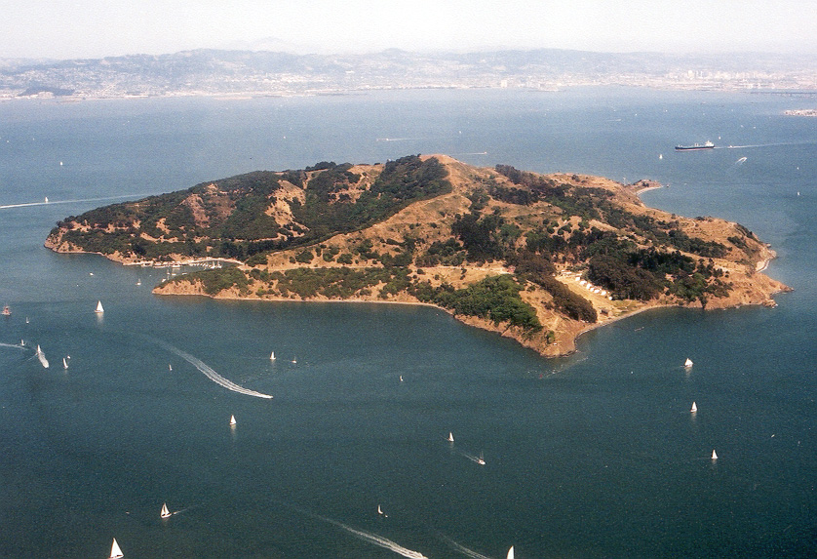

Cost

Parking $5.00  
Adult Ferry Ticket: $15.00  
Youth Ferry Ticket (6-12): $13.00  
Child Ferry Ticket (3-5): $5.00  
Toddlers (< 2): FREE  
Bicycle Transport: $1.00

Schedule

7:45 Meet at Safeway Parking Lot  
8:00 Depart for Tiburon  
10:30 AM Meet at Ferry Terminal  
11:00 AM Catch Ferry to Ayala Cove  
11:30 AM Start Activities

Choose From Three Great Activities

**Hiking:** 4.1 mile loop trail to the top of Mt Livermore (780 ft of elevation, est. 2.5 hours)

**Biking:** 5.0 mile loop trail on a paved service road with no cars. (400 ft of elevation gain, est. 2 hours). Bring your own Bike!

**History:** Visit the Ellis Island of the west coast. A short, comfortable walk from the ferry landing. (1.5 miles each way, 180 ft of elevation gain)

***EVENT INFORMATION***

Contact Steve Brewer @ 916.768.6777 or iambrewer@gmail.com

**Angel Island  
Saturday, October 11**