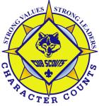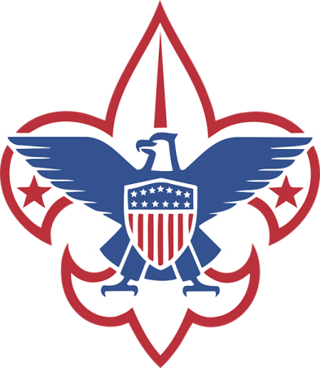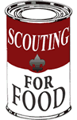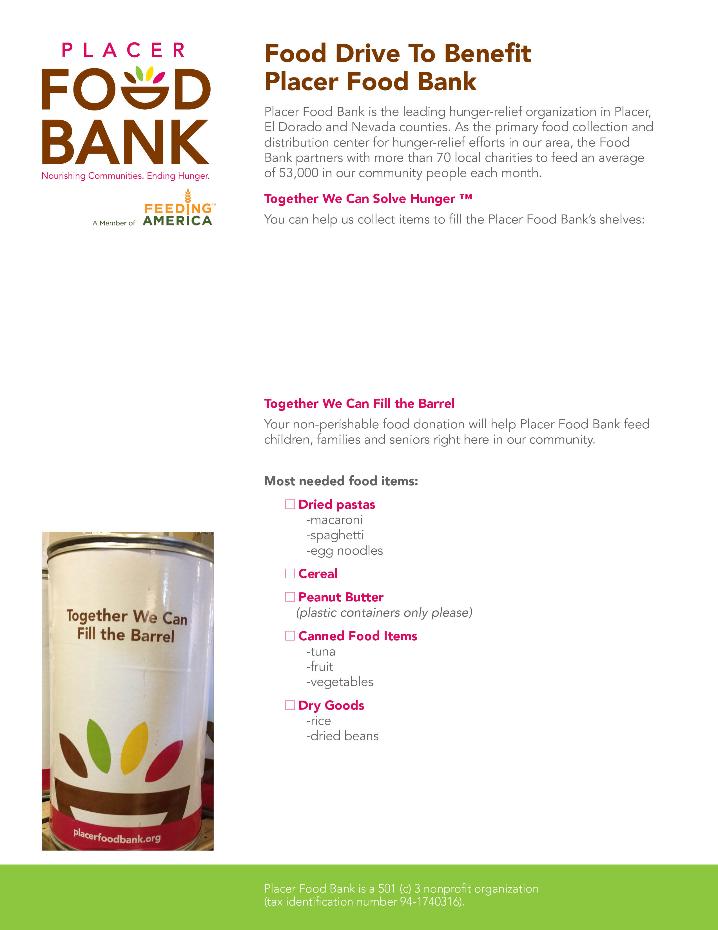

Placer Food Bank is the leading hunger-relief organization in Placer, El Dorado and Nevada counties. As the primary food collection and distribution center for hunger-relief efforts in our area, the Food Bank partners with more than 70 local charities to feed an average of 53,000 people in our community each month.

Any Non-Perishable Non-Expired Food Item Will Be Gratefully Accepted

**Thank You for Supporting Scouting for Food!**

**Placer Food Bank is a 501(c)3 nonprofit organization**

**(tax identification number 94-1740316).**

**Cub Scout Pack 1592**   
and the BSA are proud to be Scouting for Food

Help us fill the warehouse for Easter Dinner!!

* Food Drive Date: Saturday, April 5, 2014
* Scouts will come to your door!
* Times: between 9 AM and 11 AM.
* **Please leave non-perishable food items in this bag on your front porch Saturday for pick up.**