VISIT THE SCOUT STORE AND PURCHASE
A UNIFORM AND WOLF ACHIEVEMENT BOOK

River City Scout Shop
251 Commerce Cir
Sacramento, CA 95815
Telephone (916) 649-1800
Fax: (916) 649-1177
Hours of Operation:
Mon., Tue., Thu., Fri. 9:00 am - 6:00 pm
Wed. 9:00 am - 6:30 pm
Sat. 10:00 am - 4:00 pm

What to Buy
- Achievement Book (recommend ringed one) $12.99-$18.99
- Blue Short Sleeve Uniform Shirt - $24.99
- Blue Belt - $9.99
- Neckerchief - $8.99
- Scout Neckerchief Slide - $5.99
- Scout Hat (Optional) - $14.99
- Insignia/Patches $8.65
We recommend buying a size larger than your scout wears today
Estimated Cost
$70 (without hat)

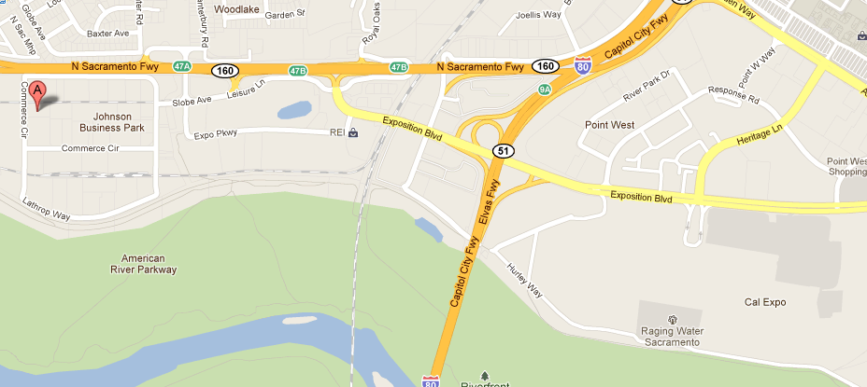

PATCHES TO PURCHASE
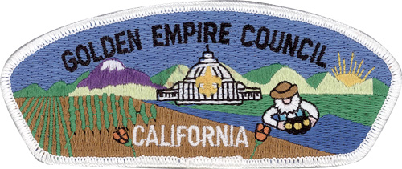
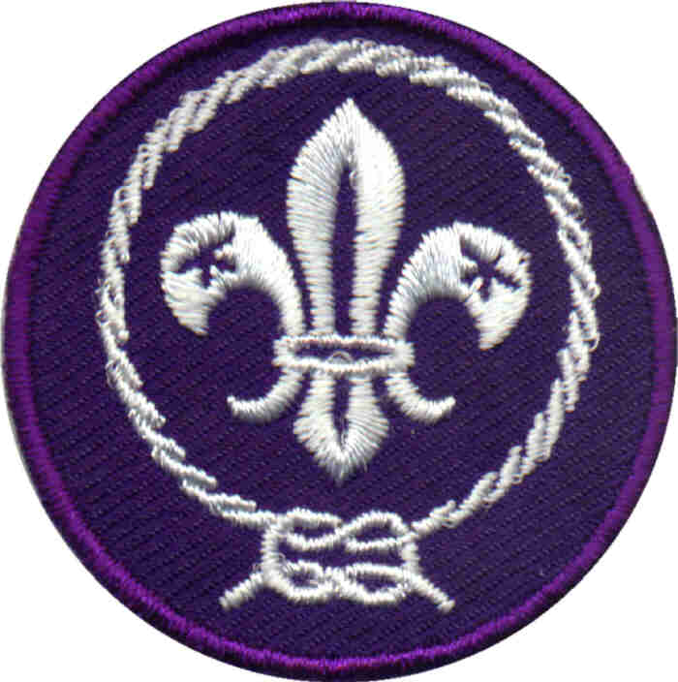

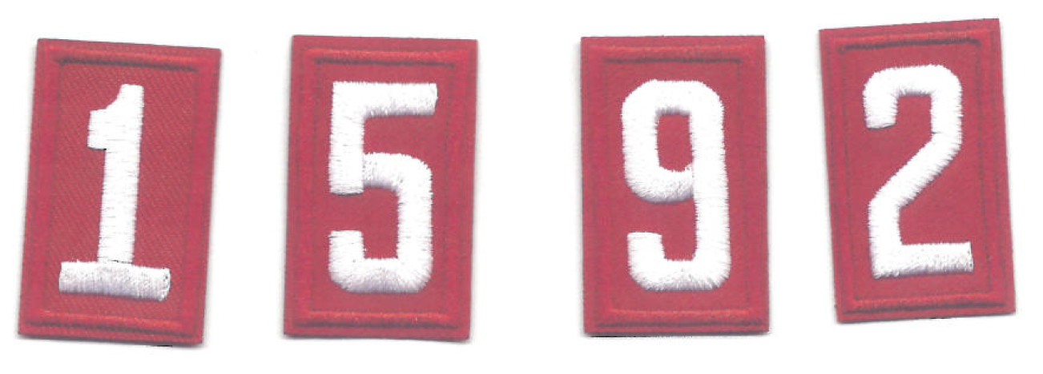

PATCH PLACEMENT
